

FC308 Practical Programming Assignment – Part 2

I confirm that this assignment is my own work. Where I have referred to academic sources, I have provided in-text citations and included the sources in the final reference list.

KAPLAN INTERNATIONAL COLLEGE LONDON – IYO COMPUTER SCIENCE PROGRAMME Module Title : Information Technology Module Code : FC308

Module Title : Information Technology

Module Code : FC308

Pnumber: p422027

Name: Gabriel Paniroi Haposan Siallagan

**Table of Contents**

|  |  |  |
| --- | --- | --- |
| **No:** | **Topic** | **Page Number** |
| 1 | Analysis | 2 |
| 2 | Design | 3-19 |
| 3  3.1  3.2  3.3  3.4 | Technical Evaluation  Libraries/Modules used  Functions Used From Respective Libraries/Modules  Built-in Python Functions  Classes | 21  22-24  24-25  25 |
| 4 | Code with Comments | 33-51 |
| 5  5.1  5.2 | Testing  Testing for Development  Testing for Evaluation | 52-53  54-62 |
| 6 | Evaluation and Summary | 63 |
| 7 | Reference | 64 |

1. Analysis

The Budget Planner application addresses the challenge of helping users effectively manage and visualize their personal finances through a user-friendly platform. The program's main goal is to let users to set up personal accounts so they may enter, monitor, and evaluate budgetary data. The program guarantees the safe and effective management of personal financial information by storing each user's data in distinct JSON files. In order to maintain a clear and straightforward user experience, providing smooth data synchronisation across several frames in the main window posed a significant problem during the application's development. Moreover, handling JSON files for the first time introduced complexities in data storage and retrieval, requiring careful implementation to prevent data inconsistencies. The program's capacity to give users precise and understandable financial facts so they may make well-informed decisions regarding their spending and saving practices is critical to its success. The program efficiently handles numerous user accounts and budgets, but as the user base increases, scalability concerns and the requirement for more sophisticated financial analytics will likely restrict its usefulness. With an eye towards simplicity, the application aims to combine extensive budget management capabilities with an intuitive user interface that can be used by users with different degrees of financial literacy. Future enhancements may address these limitations by incorporating more sophisticated data analysis tools and exploring alternative data storage solutions to accommodate a larger audience.

1. Design

Program Budget Tracker

**Initital Set Up**

Import csv

Import json

Import os

Import tkinter library as Tk

Import messagebox from tkinter

Import ttk from tkinter

Import matplotlib.pyplot as plt

Import FigureCanvasTkAgg from matplotlib.backends.backend_tkagg

Define constant FILE as "/Users/gabrielsiallagan/Desktop/information systems/users.csv"

**Preparation Classes**

**Class UserManager**:

Initialize user data from CSV file

Function __init__():

self.data = reader()

Login with username and password

Function login(username, password):

Return True if username exists in self.data and self.data[username] is equal to password

Else return False

Sign up with a new username and password

Function signup(username, password):

If username exists in self.data:

Return False

Else:

self.data[username] equal to password

writer(self.data)

Return True

Read CSV file and return dictionary of users

Function reader():

data = empty dictionary

Open FILE in read mode as csvfile

Initialize reader as csv.reader(csvfile)

For each row in reader:

If row has at least 2 elements:

data[row[0]] = row[1] // Map username to password

Return data

Write user data to CSV file

Function writer(data):

Open FILE in write mode as csv_file

Initialize writer as csv.writer(csv_file, delimiter=',')

For each username, password in data.items():

writer.writerow([username, password])

**Class UserDataManager**:

Initialize user data and file path

Function __init__(current_user):

self.filepath = "/Users/gabrielsiallagan/Desktop/information systems/" + current_user + "_data.json"

self.data = load_data()

self.subscribers = empty list

// Save updated data to JSON file and notify subscribers

Function save_data():

Open self.filepath in write mode as file

Dump self.data to file as JSON

Call notify_subscribers()

// Initialize categories for monthly expenses

Function initialize_month_expenses():

Return dictionary with keys as categories: "Food", "Rent", "Utilities", "Transportation", "Shopping", "Life and Entertainment", "Other" with each value as empty list

Update user data with new income, balance, and savings goal

Function update_user_data(income, balance, savings_goal):

Set self.data["income"] = income

Set self.data["balance"] = balance

Set self.data["savings_goal"] = savings_goal

Call save_data()

Add an expense to the user's data

Function add_expense(day, amount, category):

If category exists in self.data["expenses"][day]:

Append amount to self.data["expenses"][day][category]

Else:

Initialize self.data["expenses"][day][category] = [amount]

Call save_data()

Get total expenses for each category

Function get_category_expenses():

Initialize category_totals as dictionary with keys from self.data["expenses"]["1"] set to 0

For each day, categories in self.data["expenses"].items():

For each category, amounts in categories.items():

Add sum of amounts to category_totals[category]

Return category_totals

Load data from JSON file or create new data structure if file doesn't exist

Function load_data():

If os.path.exists(self.filepath):

Open self.filepath in read mode as file

Return JSON-loaded data from file

Else:

Return dictionary with keys "income", "balance", "savings_goal" set to 0.0 and "expenses" as dictionary of days (1-28) with initialized monthly expenses

Calculate the total expenses for the month

Function total_expense():

Initialize categories list with "Food", "Rent", "Utilities", "Transportation", "Shopping", "Life and Entertainment", "Other"

Initialize monthly_expense as empty list

For each day from 1 to 28:

Initialize daily_expenses as empty list

For each category in categories:

Get sum of self.data['expenses'][day][category] and append to daily_expenses

Calculate daily_total as sum of daily_expenses

Append daily_total to monthly_expense

Calculate total_monthly_expense as sum of monthly_expense

Return total_monthly_expense

Subscribe a callback to data changes

Function subscribe(callback):

Append callback to self.subscribers

Notify all subscribers about data changes

Function notify_subscribers():

For each callback in self.subscribers:

Call callback()

**Class CenterWindow:**

Center a window on the screen

Function center_window(width, height):

Get screen_width and screen_height from window

Calculate x = (screen_width / 2) - (width / 2)

Calculate y = (screen_height / 2) - (height / 2)

Set window geometry to width x height at position x, y

**Class Construction:**

Create a frame with specified dimensions

Function create_frame(parent, dimension, side, row=None, fill=None, expand=False):

Initialize frame as Frame with parent, width=dimension[0], height=dimension[1], highlightbackground="#b09662", highlightthickness=2

Set frame to not resize based on content

If row is None:

Configure frame.column 0 with weight 1

Pack frame with pady=10, side=side, fill=fill, expand=expand

Else:

For x in range(row):

Configure frame.column x with weight 1

Pack frame with pady=10, side=side, fill=fill, expand=expand

Return frame

Create a label and entry pair on a specified row

Function create_label_entry_pair(parent, label_text, row, fontsize, show=None):

Initialize label as Label with parent, text=label_text, font=('Arial', fontsize)

Set label.grid position at row=row, column=0, sticky=W+E

Initialize entry_button_frame as Frame with parent

Set entry_button_frame.grid position at row=row, column=1, sticky=W+E

Initialize entry as Entry within entry_button_frame with font=('Arial', fontsize), show=show

Pack entry with side=LEFT, fill=X, expand=True

Return label, entry

Center a window with specified width and height

Function center_window(window, width, height):

Get screen_width and screen_height from window

Calculate x = (screen_width / 2) - (width / 2)

Calculate y = (screen_height / 2) - (height / 2)

Set window geometry to width x height at position x, y

**Window Classes**

class LOGIN(Tk, CenterWindow)

initialise (user_manager)

call super().__init__()

SET self.user_manager = user_manager

SET window title

DISABLE window resizing

call self.center_window with size

call self.create_widgets()

call self.mainloop()

function create_widgets()

call self.create_input_frame()

call self.create_buttons()

function create_input_frame()

call login_frame

configure columns

pack frame

call self.create_label_entry_pair for Username

call self.create_label_entry_pair for Password

function create_label_entry_pair(parent, label_text, row, show=None)

create label

place label in grid

create entry

place entry in grid

if row is equal to 0 THEN

set self.entry_username

else

set self.entry_password

function create_buttons()

create login_button

pack login_button

create signup_button

pack signup_button

function login()

get username from entry

get password from entry

if self.user_manager.login(username, password) then

show success message

close window

create main_window

call main_window.mainloop()

else

show error message

function open_signup_window()

create SignupWindow instance

class SignupWindow(Toplevel, CenterWindow)

initialise (login_instance)

call super().__init__()

set self.login_instance = login_instance

set window title

disable window resizing

call self.center_window with size

call self.create_widgets()

function create_widgets()

create signup_frame

configure columns

pack frame

call self.create_label_entry_pair for Username

call self.create_label_entry_pair for Password

create signup_button

pack signup_button

funciton create_label_entry_pair(parent, label_text, row, show=None)

create label

place label in grid

create entry

place entry in grid

if row is equal to 0 THEN

set self.entry_username

else

set self.entry_password

funciton signup()

get username from entry

get password from entry

if self.login_instance.user_manager.signup(username, password) then

show success message

close window

else

show error message

class FrameRight(Construction)

initialise(parent, data_manager)

set self.data_manager

create frame

configure frame

call self.expense()

subscribe self.update_table to data changes

function expense(frame)

create labels, entries, and buttons for expense

call self.Table()

function add_expense()

try

get expense_amount from entry

get expense_day from combobox

get expense_category from combobox

if expense_amount less or equal to 0 then

show error message

else

call self.data_manager.add_expense()

show success message

except non-numerical values

show error message

function expensepie()

create pie chart window

fetch data

plot pie chart

display pie chart

function Table(frame)

create table with columns

add scrollbar to table

call self.table_data()

insert data into table

pack table

function update_table()

clear existing table entries

get all expenses

insert expenses into table

function table_data()

fetch data

return formatted data

class FrameLeft(Construction)

initialise(parent, data_manager)

set self.data_manager

create frame

configure frame

initialise current values

create labels, entries, and buttons for balance, income, savings goals

subscribe self.update_frame to data changes

function calculate_daily_savings_expense()

calculate daily savings expense

function update_balance()

try

get balance_value from entry

if balance_value less or equal 0 THEN

show error message

else

update balance

show success message

except ValueError

show error message

function update_income()

try

get income_value from entry

if income_value <= 0 THEN

show error message

else

update income

show success message

except ValueError

show error message

function update_savings()

try

get savings_value from entry

if savings_value less than or equal to 0 or more than current income then

show error message

else

update savings goal

show success message

except ValueError

show error message

function update_displays()

update display labels

function get_feasibility(daily_expense)

return feasibility string based on daily expense

function update_frame()

update current values

update displays

class GraphFrame(Construction)

initialise(parent, data_manager)

set self.data_manager

create frame

subscribe self.update_graph to data changes

call self.plot_graph()

function plot_graph(frame)

initialise figure and axes

plot data

plot data

create canvas for figure

pack canvas

function get_monthly_balance(data)

calculate net balance for each day

function update_graph()

clear figure

call self.plot_graph()

**class WINDOW(Tk, Construction)**

initialise (current_user)

call super().__init__()

set window title to 'Budget Planner'

set window background color to '#0b0b0b'

call self.center_window with dimensions 1512x982

create label with text "{current_user.capitalize()}'s Budget Planner"

configure label font to 'Arial', size 30, foreground color '#b09662', background color 'black'

pack label with padding 3

create self.user_manager with current_user

create FrameRight with self and self.user_manager

create FrameLeft with self and self.user_manager

create GraphFrame with self and self.user_manager

call self.mainloop()

**Main Program Flow**

Define main function to initialize the program

create user_manager instance

create login_app instance with user_manager

call login_app.mainloop()

Call main()

1. **Technical Overview**

**3.1 Libraries/Modules used:**

csv: Used in my code to save and load user data, budget details, or any tabular data in a simple text format that is easy to read and write.

json: Used in my code to save and load user preferences, settings, or any structured data in a lightweight, text-based format that is easy to read and write.

os: Used in my code to manage file paths, create directories, and handle file operations in a platform-independent way.

* from tkinter: Used in my code to create the main window, labels, buttons, frames, and other GUI elements for my budget planner application.

messagebox from tkinter: Used in my code to display messages to the user, such as confirmation dialogs, error messages, or information alerts.

ttk from tkinter: Provides themed widgets (Treeview, Combobox, Notebook, etc.) that can be used in my code to create more visually appealing and interactive widgets in your GUI application.

matplotlib.pyplot: Used in my code to create plots, charts, and graphs to visualize budget data, such as spending trends, income vs. expenses, etc.

FigureCanvasTkAgg from matplotlib.backends.backend_tkagg:

Used in my code to display Matplotlib plots within the Tkinter GUI, allowing you to integrate graphs directly into your budget planner application.

**3.2 Functions Used From Respective Libraries/Modules**

**csv Module**

* **csv.reader()**
  + **Purpose**: Used to read data from CSV files into Python, producing an iterable reader object.
  + **Usage**: Parses CSV data into a list of rows or columns.
* **csv.writer()**
  + **Purpose**: Used to write data to CSV files.
  + **Usage**: Converts Python data into CSV format and writes it to a file.

**json Module**

* **json.dump()**
  + **Purpose**: Serializes Python objects and writes them as JSON to a file.
  + **Usage**: Used to save Python data structures like lists and dictionaries into JSON format files.
* **json.load()**
  + **Purpose**: Deserializes JSON data from a file into a Python object.
  + **Usage**: Reads JSON data from a file and converts it into corresponding Python data structures.

**os Module**

* **os.path.exists()**
  + **Purpose**: Checks if a given path exists.
  + **Usage**: Determines if a file or directory is present at the specified path.

**Tkinter Library**

**tkinter Module**

* **Tk()**
  + **Purpose**: Initializes a Tkinter application and creates a main window.
  + **Usage**: Acts as the root widget of the Tkinter GUI application.
* **Label()**
  + **Purpose**: Displays static text or images in the GUI.
  + **Usage**: Used to label different parts of the GUI with text or icons.
* **Button()**
  + **Purpose**: Creates a clickable button widget.
  + **Usage**: Used to perform actions when clicked, such as submitting forms or closing windows.
* **Entry()**
  + **Purpose**: Provides a text entry field for user input.
  + **Usage**: Collects single-line text input from the user.
* **Text()**
  + **Purpose**: Provides a multi-line text area for user input or display.
  + **Usage**: Allows users to input or display multiple lines of text.
* **Frame()**
  + **Purpose**: Acts as a container to hold and organize other widgets.
  + **Usage**: Used for grouping related widgets in the GUI for better layout management.
* **messagebox.showinfo()**
  + **Purpose**: Displays an information dialog box.
  + **Usage**: Shows information messages to the user with an OK button.
* **messagebox.showerror()**
  + **Purpose**: Displays an error dialog box.
  + **Usage**: Alerts users to errors with an OK button.
* **winfo_screenwidth()**
  + **Purpose**: Returns the width of the screen in pixels, used to calculate the center position for a window.
  + **Usage**: Calculate necessary dimensions and placement for the window for it to be centred on user screens
* **winfo_screenheight()**
  + **Purpose**: Returns the height of the screen in pixels, used to calculate the center position for a window.
  + **Usage**: Calculate necessary dimensions and placement for the window for it to be centred on user screens
* **Configure()**
  + **Purpose:** Change the properties of a widget after its initial creation.
  + **Usage:** Add colours and design of labels frames etc.

**tkinter.ttk Module**

* **ttk.Combobox()**
  + **Purpose**: Provides a dropdown list widget with a selection of items.
  + **Usage**: Allows users to select a single item from a predefined list of options.

**Matplotlib Library**

**matplotlib.pyplot Module**

* **plt.Figure()**
  + **Purpose**: Creates a new figure for plotting.
  + **Usage**: Serves as the main container for a plot and its components.
* **plt.pie()**
  + **Purpose**: Generates a pie chart.
  + **Usage**: Creates pie charts to represent data distribution visually.
* **plt.plot()**
  + **Purpose**: Plots data points on a 2D plane.
  + **Usage**: Creates line graphs and scatter plots.
* **plt.xlabel()**
  + **Purpose**: Sets the label for the x-axis.
  + **Usage**: Annotates the x-axis with a descriptive label.
* **plt.ylabel()**
  + **Purpose**: Sets the label for the y-axis.
  + **Usage**: Annotates the y-axis with a descriptive label.
* **plt.title()**
  + **Purpose**: Sets the title for the plot.
  + **Usage**: Provides a title for the chart or graph to convey its purpose.
* **plt.show()**
  + **Purpose**: Displays the plot in a window.
  + **Usage**: Renders the plot and opens it in a GUI window for viewing.

**matplotlib.backends.backend_tkagg Module**

* **FigureCanvasTkAgg()**
  + **Purpose**: Embeds a Matplotlib figure into a Tkinter widget.
  + **Usage**: Integrates Matplotlib plots into a Tkinter GUI, allowing for interactive plots within the application

**3.3 Built-in Python Functions**

* **Class**
  + **Purpose:** Creating objects that possesses certain properties and methods
* **if, else**
  + **Purpose**: Conditional statements used for control flow, determining which code blocks to execute based on conditions.
* **for loops**
  + **Purpose**: Looping statement used for iterating over sequences, such as lists, tuples, or dictionaries.
* **return**
  + **Purpose**: Exits a function and optionally returns a value to the caller.
* **with**
  + **Purpose**: Used for resource management and exception handling. It ensures that clean-up code is executed, for example, closing a file.
* **append**
  + **Purpose**: Adds an item to the end of a list. Used for adding expenses to lists and for managing subscribers.
* **items**
  + **Purpose**: Provides a view object that displays a list of dictionary's key-value tuple pairs, useful for iteration over dictionaries.
* **__init__**
  + **Purpose**: Special method that initializes newly created objects.
* **open**
  + **Purpose**: Opens a file and returns a corresponding file object, allowing for reading or writing operations.
* **super()**
  + **Purpose**: Returns a temporary object of the superclass that allows you to call its methods. Used to call the parent class’s __init__ method.
* **get()**
  + **Purpose**: Retrieves the current value of a specified key in a dictionary or, in this context, gets the text from Tkinter's Entry widget. Though not a standalone Python function, it's a method used on a variety of built-in collections.
* **strip()**
  + **Purpose**: Returns a copy of the string with leading and trailing whitespace removed.
* **lower()**
  + **Purpose**: Returns a copy of the string with all characters converted to lowercase.

**3.4 Classes**

**UserManager Class**

Purpose: The UserManager class is responsible for handling user authentication and account management. It provides functionalities for user login and signup, as well as reading from and writing to a CSV file that stores user credentials (username and password). It acts as a bridge between the application and the stored user data, allowing secure authentication and account management.

**UserDataManager Class**

**Purpose:**

The UserDataManager class is responsible for managing and persisting user-specific data related to financial information and expenses. It handles operations like loading user data from a JSON file, updating financial information, adding expenses, and notifying subscribers about data changes. This class allows users to track their financial status, monitor expenses, and make informed decisions based on up-to-date data.

def subscribe(self, callback):

"""Subscribe a callback to data changes."""

self.subscribers.append(callback)

##This method allows other parts of the application to register a callback function that will be called whenever the data changes. A callback function is a piece of code that you want to run later in response to some event, such as a data update.

def notify_subscribers(self):

"""Notify all subscribed components about data changes."""

for callback in self.subscribers:

callback()

#This method is responsible for informing all subscribed components that the data has changed. When the data changes, this method will go through each subscribed callback and execute it, ensuring that every component is updated accordingly.

Special subscriber concept used in this class:

The concept of subscribers in my code, specifically within the UserDataManager class, is an implementation of the **Observer Pattern**. This design pattern is used to allow an object to notify other interested objects (subscribers) about changes in its state. This concept was used to synchronise data in all frames within my main window such that the widgets in my code will update according to any data change made in other frames.

**CenterWindow Class**

class CenterWindow:

def center_window(self, width, height):

screen_width = self.winfo_screenwidth()

screen_height = self.winfo_screenheight()

x = (screen_width / 2) - (width / 2)

y = (screen_height / 2) - (height / 2)

self.geometry(f"{width}x{height}+{int(x)}+{int(y)}")

**Purpose:**

The CenterWindow class provides a utility function for centering windows on the screen. This is particularly useful for graphical user interfaces (GUIs) where you want to position windows centrally for better user experience.

**Construction Class**

**Purpose:**

The Construction class is a utility class designed to simplify the creation and layout of GUI components, such as frames, labels, and entry fields, in a Tkinter application. It provides methods to consistently style and position these elements, making the GUI development process more streamlined.

***The classes listed above were created for convenience in construction of the main windows which proved to be important in making the main window codes easier to read.***

LOGIN Class

Purpose:

creates the login window. It inherits the Tk which is the main window class in Tkinter. Additionally, it inherits the CenterWindow class to be centered on the users screens.

def login(self):

username = self.entry_username.get().strip().lower()

password = self.entry_password.get()

if self.user_manager.login(username, password):

messagebox.showinfo("Login", "Login Successful!")

self.destroy()

main_window = WINDOW(username)

main_window.mainloop()

else:

messagebox.showerror("Login", "Invalid username or password.")

The method login() is used for error handling for when users type in an invalid password or a username that does not exist within the file. .strip() and .lower() makes the username case insensitive and removes any additional spaces that users may have accidentally typed in. Message pop ups will advise users on what went wrong in the login accordingly. Main window will only open when login is successful.

SignupWindow Class

Purpose:

creates the signup page when users want to register an account. It inherits TopLevel, a tkinter class used to create new windows separate from the main application window. This allows the signup process to occur in a distinct interface, enhancing user experience.

def signup(self):

username = self.entry_username.get().strip().lower()

password = self.entry_password.get()

if self.login_instance.user_manager.signup(username, password):

messagebox.showinfo("Sign Up", "Sign Up Successful!")

self.destroy()

else:

messagebox.showerror("Sign Up", "Username already exists.")

The method signup() is used for error handling for when users type in a username that already exists in the file. Message pop ups will inform users on what went wrong in the login accordingly. Once user has successfully made an account, signup window will close immediately.

FrameRight Class

Purpose:

The FrameRight class is a part of the window and is responsible for managing a right-hand frame within the GUI. This frame is designed for managing and displaying expense data. The class provides functionality for adding new expenses, visualizing expenses in a pie chart, and displaying expense data in a tabular format.

# Subscribe to data changes

self.data_manager.subscribe(self.update_table)#if there is a change in data from any other frame, table will update

def update_table(self):

"""Refresh the expense table with current data."""

# Clear existing entries in the table

for item in self.tree.get_children():

self.tree.delete(item)

# Get all expense data

all_expenses = self.table_data()

# Insert data into the table

for expense in all_expenses:

day, category, amount = expense

self.tree.insert("", END, values=(day, category, amount))

As mentioned previously, within this frame, subscribe function is used to callback the update_table() function. This is so that the treeview Table would be updated after any changes in the expenses and would express the expenses in order of the date.

FrameLeft Class

Purpose:

The FrameLeft class is a part of the window and is responsible for managing a left-hand frame within the GUI. This frame is designed for managing and displaying expense data. The class provides functionality for adding new expenses, visualizing expenses in a pie chart, and displaying expense data in a tabular format.

self.data_manager.subscribe(self.update_frame)

def update_displays(self):

"""Updates all display labels to reflect the current state."""

# Calculate the new balance and net balance

self.new_balance = self.current_balance + self.current_income

self.total_expense = self.data_manager.total_expense()

self.net_balance = self.new_balance - self.total_expense

# Update display labels with new values

self.new_balance_display.config(text=f"Balance after Income: ${self.new_balance:.2f}")

self.total_expense_display.config(text=f"Total Expense: ${self.total_expense:.2f}")

self.net_balance_display.config(text=f"Net Balance: ${self.net_balance:.2f}")

# Update the daily savings expense

daily_savings_expense = self.calculate_daily_savings_expense()

self.daily_savings_expense_display.config(text=f"Daily Savings Expense: ${daily_savings_expense:.2f}")

# Update feasibility display

if self.get_feasibility(daily_savings_expense) == "Not Feasible":

self.feasibility_display.config(text=self.get_feasibility(daily_savings_expense),fg = '#f00e29', bg = '#797d7f')

elif self.get_feasibility(daily_savings_expense) == "Possible but difficult":

self.feasibility_display.config(text=self.get_feasibility(daily_savings_expense),fg = '#f27c1b', bg = '#797d7f')

elif self.get_feasibility(daily_savings_expense) == "Possible":

self.feasibility_display.config(text=self.get_feasibility(daily_savings_expense), fg = '#14d368', bg = '#797d7f')

As mentioned previously, within this frame, subscribe function is used to callback the update_displays() function. This is so that the display showing the users data would be updated after any new expenses.

GraphFrame class

The main purpose of the GraphFrame class is to visually represent and track financial data over a month, displaying trends in expenses, income, and savings goals through a dynamic and interactive graph. This class is designed to be a part of a larger application that helps users manage and analyze their financial status, providing insights into their spending habits and financial goals.

self.data_manager.subscribe(self.update_graph)

def update_graph(self):

"""Updates the graph with new data when notified of data changes."""

# If the figure exists, clear the axes

if self.fig:

self.fig.clear()

# Create new axes

ax = self.fig.add_subplot(111)

# Retrieve updated data

self.days = list(range(1, 29)) # Assuming 28 days for simplicity

self.numbers = self.get_monthly_balance(self.data_manager.data)

# Update income and savings goal for visualization

monthly_income = self.data_manager.data["income"]

monthly_savings_goal = self.data_manager.data["savings_goal"] + (self.data_manager.data["balance"])

self.income = [monthly_income] * 28 # Distribute monthly income equally

self.savings_goal = [monthly_savings_goal] * 28 # Distribute savings goal equally

# Plot the updated data

ax.plot(self.days, self.numbers, color='blue', linewidth=2, marker='o', markerfacecolor='blue', markersize=3, label='Expenses')

ax.plot(self.days, self.income, color='green', linewidth=1, linestyle='dotted', label='Income')

ax.plot(self.days, self.savings_goal, color='red', linewidth=1, linestyle='dotted', label='Savings Goal')

# Update labels and title

ax.set_xlabel('Days')

ax.set_ylabel('Amount ($)')

ax.set_ylim(bottom=0)

ax.set_title('Expenses Graph')

ax.legend(loc='upper right', fontsize = 10) # Add legend

# Adjust ticks

ax.tick_params(axis='both', which='major', labelsize=10) # Adjust the labelsize as needed

# Redraw the canvas with the new figure

self.canvas.draw()

within this frame, subscribe function is used to callback the update_graph() function. This is so that the display showing the users data would be updated after any adjustments to the data. This is done by deleting the previous graph using .clear() function and plotting a brand new graph.

Window Class

class WINDOW(Tk, Construction):

def __init__(self, current_user):

super().__init__()

self.title('Budget Planner')

self.configure(bg = '#0b0b0b')

self.geometry('1512x982')

self.label = Label(self, text= f"{current_user.capitalize()}'s Budget Planner", font=('Arial', 30), fg = '#b09662', bg = 'black')

self.label.pack(pady=3)

# Create a single data manager for the whole application

self.user_manager = UserDataManager(current_user)

# Pass the data manager to each frame

FrameRight(self, self.user_manager)

FrameLeft(self, self.user_manager)

GraphFrame(self, self.user_manager)

Purpose:

Creates the main window that sets up all the widgets and functions from the respective frames(found in FrameRight, FrameLeft, GraphFrame). It sets the window title, background color, and size. Addtionally it Instantiate UserDataManager with the current_user to manage user-specific data and passes the user_manager to different frames for managing different parts of the UI.

Mainline

if __name__ == "__main__":

#define UserManager class to call in LOGIN class

user_manager = UserManager()

login_app = LOGIN(user_manager)

if __name__ == “__main__” function was used to ensure that the code is being run as the mainline.

1. **Code with Comments**

##########################IMPORTED LIBRARIES###############################

import csv

import json

import os

from tkinter import *

from tkinter import messagebox

from tkinter import ttk

import matplotlib.pyplot as plt

from matplotlib.backends.backend_tkagg import FigureCanvasTkAgg

##########################PREPERATION_CLASSES################################

# Define FILE to for convenience when calling

FILE = "/Users/gabrielsiallagan/Desktop/information systems/users.csv"

#used to retrieve and update data in login and sign-up class

class UserManager:

#function that is automatically called when creating the object

def __init__(self):

self.data = self.reader()

#reads file into dictionary

def login(self, username, password):

return username in self.data and self.data[username] == password

#return either 'true' or 'false' if user has an account and password is valid

def signup(self, username, password):

if username in self.data:

return False

#return false if user already has an account

self.data[username] = password

self.writer(self.data)

#adds new account into csv file

return True

#main reader function that turns csv data into a dictionary

def reader(self):

data = {}

with open(FILE, mode='r') as csvfile:

reader = csv.reader(csvfile)

#reader object

data = dict((row[0], row[1]) for row in reader if len(row) >= 2)

#creates the dictionary

return data

def writer(self, data):

with open(FILE, 'w', newline='') as csv_file:

writer = csv.writer(csv_file, delimiter=',')

#writer object

for username, password in data.items():

writer.writerow([username, password])

#splits list variable into rows

class UserDataManager:

def __init__(self, current_user):

self.filepath = "/Users/gabrielsiallagan/Desktop/information systems/" + current_user + "_data.json"

self.data = self.load_data()

#reads data

# Subscribers for data changes

self.subscribers = []

#re-writes data according to updated data

def save_data(self):

with open(self.filepath, 'w') as file:

json.dump(self.data, file, indent=2)

self.notify_subscribers()

#set up dictionary with categories

def initialize_month_expenses(self):

"""Initializes a dictionary for monthly expenses with categories."""

return {

"Food": [],

"Rent": [],

"Utilities": [],

"Transportation": [],

"Shopping": [],

"Life and Entertainment": [],

"Other": []

}

#get updated data and saves it into file

def update_user_data(self, income, balance, savings_goal):

"""Updates user income, balance, and savings goal."""

self.data["income"] = income

self.data["balance"] = balance

self.data["savings_goal"] = savings_goal

self.save_data()

#adds new expense with date and category into the file

def add_expense(self, day, amount, category):

"""Adds an expense to a specific user for a given month."""

if category in self.data["expenses"][str(day)]:

self.data["expenses"][str(day)][category].append(amount)

else:

self.data["expenses"][str(day)][category] = [amount]

self.save_data()

#get total expense of each category for pie chart

def get_category_expenses(self):

"""Calculates total expenses per category."""

category_totals = {category: 0 for category in self.data["expenses"]["1"]} # Initialize totals

for day, categories in self.data["expenses"].items():

for category, amounts in categories.items():

category_totals[category] += sum(amounts)

return category_totals

#reads or creates file

def load_data(self):

if os.path.exists(self.filepath):

with open(self.filepath, 'r') as file:

return json.load(file)

else:

return {

"income": 0.0,

"balance": 0.0,

"savings_goal": 0.0,

"expenses": {str(day): self.initialize_month_expenses() for day in range(1, 29)}

}

#calculates total expense

def total_expense(self):

categories = ["Food", "Rent", "Utilities", "Transportation", "Shopping", "Life and Entertainment", "Other"]

# Initialize list to hold monthly expenses

monthly_expense = []

# Iterate over each day

for day in range(1, 29): # Use the actual range of days as integers

day_str = str(day) # Convert day to string to use as a key in the JSON data

daily_expenses = [] # List to store daily expenses per category

# Check if the day exists in the data

for category in categories:

# Check if the category exists for the day, and sum the expenses if it does

category_sum = sum(self.data['expenses'][day_str].get(category, []))

daily_expenses.append(category_sum)

# Calculate the total expenses for the day

daily_total = sum(daily_expenses)

# Append daily total to monthly expenses

monthly_expense.append(daily_total)

total_monthly_expense = sum(monthly_expense)

# Print the list of monthly expenses

return total_monthly_expense

def subscribe(self, callback):

"""Subscribe a callback to data changes."""

self.subscribers.append(callback)

##This method allows other parts of the application to register a callback function that will be called whenever the data changes. A callback function is a piece of code that you want to run later in response to some event, such as a data update.

def notify_subscribers(self):

"""Notify all subscribed components about data changes."""

for callback in self.subscribers:

callback()

#This method is responsible for informing all subscribed components that the data has changed. When the data changes, this method will go through each subscribed callback and execute it, ensuring that every component is updated accordingly.

#to be called in login and signup to center window

class CenterWindow:

def center_window(self, width, height):

screen_width = self.winfo_screenwidth()

screen_height = self.winfo_screenheight()

x = (screen_width / 2) - (width / 2)

y = (screen_height / 2) - (height / 2)

self.geometry(f"{width}x{height}+{int(x)}+{int(y)}") ## The following lines of code were adapted from https://www.youtube.com/watch?v=TdTks2eSx3c&ab_channel=Codemy.com

#class helps with the creation of frames

class Construction:

#frame creation function

def create_frame(self, parent, dimension, side, row=None, fill=None, expand=False):

frame = Frame(parent, width=dimension[0], height=dimension[1], highlightbackground="#b09662", highlightthickness=2)

frame.pack_propagate(False) # Prevent the frame from resizing based on its content

if row is None:

frame.columnconfigure(0, weight=1)

frame.pack(pady=10, side=side, fill=fill, expand=expand)

else:

for x in range(row):

frame.columnconfigure(x, weight=1)

frame.pack(pady=10, side=side, fill=fill, expand=expand)

return frame

#creates a label and an entry side by side

def create_label_entry_pair(self, parent, label_text, row, fontsize, show=None):

label = Label(parent, text=label_text, font=('Arial', fontsize))

label.grid(row=row, column=0, sticky=W+E)

# Frame to contain both Entry and Button

entry_button_frame = Frame(parent)

entry_button_frame.grid(row=row, column=1, sticky=W+E)

entry = Entry(entry_button_frame, font=('Arial', fontsize), show=show)

entry.pack(side=LEFT, fill=X, expand=True) # Use pack for entry in this frame

return label, entry # Return the entry widget for later use

# Add 'window' parameter to specify the window to be centered

def center_window(self, window, width, height):

screen_width = window.winfo_screenwidth()

screen_height = window.winfo_screenheight()

x = (screen_width / 2) - (width / 2)

y = (screen_height / 2) - (height / 2)

window.geometry(f"{width}x{height}+{int(x)}+{int(y)}") ## The following lines of code were adapted from https://www.youtube.com/watch?v=TdTks2eSx3c&ab_channel=Codemy.com

####################################################################

###########################LOGIN_WINDOW#############################

class LOGIN(Tk, CenterWindow):

def __init__(self, user_manager):

super().__init__()

self.user_manager = user_manager

self.title("Login/Signup")

self.resizable(False, False)

self.center_window(500, 200)

self.create_widgets()

self.mainloop()

def create_widgets(self):

self.create_input_frame()

self.create_buttons()

def create_input_frame(self):

self.login_frame = Frame(self)

self.login_frame.columnconfigure(0, weight=1)

self.login_frame.columnconfigure(1, weight=1)

self.login_frame.pack(padx=20, pady=(20, 0), fill=BOTH, expand=False)

self.create_label_entry_pair(self.login_frame, "Username: ", 0)

self.create_label_entry_pair(self.login_frame, "Password: ", 1, show='*')

def create_label_entry_pair(self, parent, label_text, row, show=None):

label = Label(parent, text=label_text, font=('Arial', 18))

label.grid(row=row, column=0, sticky=W+E, pady=10)

entry = Entry(parent, font=('Arial', 18), show=show)

entry.grid(row=row, column=1, sticky=W+E, pady=10)

if row == 0:

self.entry_username = entry

else:

self.entry_password = entry

def create_buttons(self):

self.login_button = Button(self, text='Login', font=('Arial', 15), command=self.login)

self.login_button.pack()

self.signup_button = Button(self, text='Sign Up', font=('Arial', 15), command=self.open_signup_window)

self.signup_button.pack()

def login(self):

username = self.entry_username.get().strip().lower()

password = self.entry_password.get()

if self.user_manager.login(username, password):

messagebox.showinfo("Login", "Login Successful!")

self.destroy()

main_window = WINDOW(username)

main_window.mainloop()

else:

messagebox.showerror("Login", "Invalid username or password.")

def open_signup_window(self):

SignupWindow(self)

######################################################################

############################SIGN-UP_WINDOW############################

#toplevel used to create a window on top of a window

class SignupWindow(Toplevel, CenterWindow):

def __init__(self, login_instance):

super().__init__()

self.login_instance = login_instance

self.title("Sign Up")

self.resizable(False, False)

self.center_window(500, 200)

self.create_widgets()

#widgets within this window

def create_widgets(self):

self.signup_frame = Frame(self)

self.signup_frame.columnconfigure(0, weight=1)

self.signup_frame.columnconfigure(1, weight=1)

self.signup_frame.pack(padx=20, pady=(20, 0), fill=BOTH, expand=False)

self.create_label_entry_pair(self.signup_frame, "Username: ", 0)

self.create_label_entry_pair(self.signup_frame, "Password: ", 1, show='*')

self.signup_button = Button(self, text='Sign Up', font=('Arial', 15), command=self.signup)

self.signup_button.pack()

#creates a label and entry specific to login page

def create_label_entry_pair(self, parent, label_text, row, show=None):

label = Label(parent, text=label_text, font=('Arial', 18))

label.grid(row=row, column=0, sticky=W+E, pady=10)

entry = Entry(parent, font=('Arial', 18), show=show)

entry.grid(row=row, column=1, sticky=W+E, pady=10)

if row == 0:

self.entry_username = entry

else:

self.entry_password = entry

#function for users to make an account

def signup(self):

username = self.entry_username.get().strip().lower()

password = self.entry_password.get()

if self.login_instance.user_manager.signup(username, password):

messagebox.showinfo("Sign Up", "Sign Up Successful!")

self.destroy()

else:

messagebox.showerror("Sign Up", "Username already exists.")

################################################################################

###########################MAIN_WINDOW_FRAMES###################################

#to be added in the main window class

class FrameRight(Construction):

def __init__(self, parent, data_manager):

self.data_manager = data_manager

self.widget_frame_right = self.create_frame(parent, (300, 300), RIGHT, row=None, fill='y')

self.widget_frame_right.configure(bg='#1c1d20')

self.expense(self.widget_frame_right)

# Subscribe to data changes

self.data_manager.subscribe(self.update_table)#if there is a change in data from any other frame, table will update

#expense widgets

def expense(self, frame):

Label(frame, text='Add Expense', fg = '#b09662', bg = '#421d59').grid(row=0, column=0, columnspan=2)

self.expense_amount = self.create_label_entry_pair(frame, 'Amount:', 1, 13)

self.expense_amount_label, self.expense_amount_entry = self.expense_amount

self.expense_amount_label.configure(fg = '#b09662', bg = '#421d59')

Label(frame, text="Date:", fg = '#b09662', bg = '#421d59').grid(row=2, column=0, sticky=W)

self.expense_day = ttk.Combobox(frame, values=list(range(1, 29))) # More concise way to list days

self.expense_day.grid(row=2, column=1)

Label(frame, text="Category:", fg = '#b09662', bg = '#421d59').grid(row=3, column=0, sticky=W)

self.expense_category = ttk.Combobox(frame, values=["Food", "Rent", "Utilities", "Transportation", "Shopping", "Life and Entertainment", "Other"])

self.expense_category.grid(row=3, column=1)

Button(frame, text="Add Expense", font=('Arial', 15), command=self.add_expense, highlightbackground='#b09662').grid(row=4, column=0, columnspan=2, pady=10)

Button(frame, text="View Expense", font=('Arial', 15), command=self.expensepie, highlightbackground='#b09662').grid(row=5, column=0, columnspan=2, pady=10)

self.Table(frame)

#gets input from entries and adds to file

def add_expense(self):

try:

# Validate inputs

expense_amount = float(self.expense_amount[1].get())

expense_day = int(self.expense_day.get())

expense_category = self.expense_category.get()

#error handling

if expense_amount <= 0:

messagebox.showerror("Invalid Input", "Please enter a postive amount.")

else:

# Update the data manager

self.data_manager.add_expense(expense_day, expense_amount, expense_category)#add to file

messagebox.showinfo("Success", "Expense added successfully.")

except ValueError:

messagebox.showerror("Invalid Input", "Please enter valid numbers for amount and day.")

#piechart widget

def expensepie(self):

# Create a new Toplevel window

pie_window = Toplevel(self.widget_frame_right)

pie_window.title("Expense Distribution")

# Center the Toplevel window instead of the main window

self.center_window(pie_window, 700, 500)

# Create the pie chart

fig, ax = plt.subplots()

# Get the total expenses per category

category_expenses = self.data_manager.get_category_expenses()

categories = list(category_expenses.keys())

amounts = list(category_expenses.values())

ax.pie(amounts, labels=categories, textprops={'fontsize': 10}, autopct='%1.1f%%')

ax.axis('equal') # Equal aspect ratio ensures that pie is drawn as a circle

plt.title('Monthly Expenses Distribution')

# Create a canvas for the figure and add it to the Toplevel window

canvas = FigureCanvasTkAgg(fig, master=pie_window)

canvas.draw()

canvas.get_tk_widget().pack(fill=BOTH, expand=True)

# Ensure that the window is closed properly

pie_window.protocol("WM_DELETE_WINDOW", pie_window.destroy)

#table widget

def Table(self, frame):

self.entry_frame = self.create_frame(frame, (500, 600), BOTTOM)

self.tree = ttk.Treeview(self.entry_frame, columns=("Day", "category", "Amount"), show='headings', height = 40)

# Define the column headings

self.tree.heading("Day", text="Day")

self.tree.heading("category", text="Category")

self.tree.heading("Amount", text="Amount")

# Define the column width

self.tree.column("Day", width=50)

self.tree.column("category", width=150)

self.tree.column("Amount", width=50)

# Add a scrollbar to the Treeview

scrollbar = ttk.Scrollbar(self.entry_frame, orient=VERTICAL, command=self.tree.yview)

self.tree.configure(yscroll=scrollbar.set)

scrollbar.pack(side=RIGHT, fill=Y)

self.table_data()

for expense in self.all_expenses:

day, category, amount = expense

self.tree.insert("", END, values=(day, category, amount))

self.tree.pack(side=TOP)

#updates treeview table after every expense entry

def update_table(self):

"""Refresh the expense table with current data."""

# Clear existing entries in the table

for item in self.tree.get_children():

self.tree.delete(item)

# Get all expense data

all_expenses = self.table_data()

# Insert data into the table

for expense in all_expenses:

day, category, amount = expense

self.tree.insert("", END, values=(day, category, amount))

#to get data to insert into treeview table

def table_data(self):

categories = ["Food", "Rent", "Utilities", "Transportation", "Shopping", "Life and Entertainment", "Other"]

days = list(self.data_manager.data['expenses'].keys())

self.all_expenses = [

[day, category, expense]

for day in days

for category in categories

for expense in self.data_manager.data['expenses'][day][category]

]

return self.all_expenses

#to be added in the main window class

class FrameLeft(Construction):

def __init__(self, parent, data_manager):

self.data_manager = data_manager

self.widget_frame_left = self.create_frame(parent, (300, 300), LEFT, row=None, fill='y')

self.widget_frame_left.configure(bg='#1c1d20')

# Initialize the current values

self.current_balance = data_manager.data["balance"]

self.current_income = data_manager.data["income"]

self.current_savings_goal = data_manager.data["savings_goal"]

self.total_expense = self.data_manager.total_expense()

self.new_balance = self.current_balance + self.current_income

self.net_balance = self.new_balance - self.total_expense

# Create Balance Entry and Button

balance_label, self.balance_entry = self.create_label_entry_pair(self.widget_frame_left, "Balance", 0, 18)

balance_label.configure(fg = '#b09662', bg = '#421d59')

self.balance_button = Button(self.widget_frame_left, text="Update", font=('Arial', 15), command=self.update_balance, highlightbackground='#b09662')

self.balance_button.grid(row=0, column=2, sticky=W, padx=(5, 0))

# Create Income Entry and Button

income_label, self.income_entry = self.create_label_entry_pair(self.widget_frame_left, "Income", 1, 18)

income_label.configure(fg = '#b09662', bg = '#421d59')

self.income_button = Button(self.widget_frame_left, text="Update", font=('Arial', 15), command=self.update_income, highlightbackground='#b09662')

self.income_button.grid(row=1, column=2, sticky=W, padx=(5, 0))

# Create Savings Goals Entry and Button

savings_label, self.savings_entry = self.create_label_entry_pair(self.widget_frame_left, "Monthly Savings Goals", 2, 18)

savings_label.configure(fg = '#b09662', bg = '#421d59')

self.savings_button = Button(self.widget_frame_left, text="Update", font=('Arial', 15), command=self.update_savings, highlightbackground='#b09662')

self.savings_button.grid(row=2, column=2, sticky=W, padx=(5, 0))

# Create Display Labels for stats at the bottom of the frame

self.balance_display = Label(self.widget_frame_left, text=f"Initial Balance: ${self.current_balance:.2f}", font=('Arial', 20), fg = '#14d368', bg = '#797d7f')

self.balance_display.grid(row=3, column=0, columnspan=3, sticky=W, pady=(100, 15))

self.income_display = Label(self.widget_frame_left, text=f"Current Income: ${self.current_income:.2f}", font=('Arial', 20), fg = '#1559d7', bg = '#797d7f')

self.income_display.grid(row=4, column=0, columnspan=3, sticky=W, pady=15)

self.new_balance_display = Label(self.widget_frame_left, text=f"Balance after Income: ${(self.new_balance):.2f}", font=('Arial', 20), fg = '#14d368', bg = '#797d7f')

self.new_balance_display.grid(row=5, column=0, columnspan=3, sticky=W, pady=15)

self.total_expense_display = Label(self.widget_frame_left, text=f"Total Expense: ${(self.total_expense):.2f}", font=('Arial', 20), fg = '#f00e29', bg = '#797d7f')

self.total_expense_display.grid(row=6, column=0, columnspan=3, sticky=W, pady=15)

self.net_balance_display = Label(self.widget_frame_left, text=f"Net Balance: ${(self.net_balance):.2f}", font=('Arial', 20), fg = '#14d368', bg = '#797d7f')

self.net_balance_display.grid(row=7, column=0, columnspan=3, sticky=W, pady=15)

self.savings_display = Label(self.widget_frame_left, text=f"Monthly Savings Goal: ${self.current_savings_goal:.2f}", font=('Arial', 20), fg = '#14d368', bg = '#797d7f')

self.savings_display.grid(row=8, column=0, columnspan=3, sticky=W, pady=15)

self.daily_savings_expense_display = Label(self.widget_frame_left, text=f"Daily Savings Expense: ${self.calculate_daily_savings_expense():.2f}", font=('Arial', 20), fg = '#14d368', bg = '#797d7f')

self.daily_savings_expense_display.grid(row=9, column=0, columnspan=3, sticky=W, pady=15)

#feasibility font colour is dependent on feasiblity it self

if self.get_feasibility(self.calculate_daily_savings_expense()) == "Not Feasible":

self.feasibility_display = Label(self.widget_frame_left, text=self.get_feasibility(self.calculate_daily_savings_expense()), font=('Arial', 20), fg = '#f00e29', bg = '#797d7f')

elif self.get_feasibility(self.calculate_daily_savings_expense()) == "Possible but difficult":

self.feasibility_display = Label(self.widget_frame_left, text=self.get_feasibility(self.calculate_daily_savings_expense()), font=('Arial', 20), fg = '#f27c1b', bg = '#797d7f')

elif self.get_feasibility(self.calculate_daily_savings_expense()) == "Possible":

self.feasibility_display = Label(self.widget_frame_left, text=self.get_feasibility(self.calculate_daily_savings_expense()), font=('Arial', 20), fg = '#14d368', bg = '#797d7f')

self.feasibility_display.grid(row=10, column=0, columnspan=3, sticky=W, pady=15)

# Subscribe to data changes

self.data_manager.subscribe(self.update_frame)

def calculate_daily_savings_expense(self):

"""Calculates the daily amount available after the savings goal is subtracted from the income."""

#self.current_income and self.current_savings_goal cannot be 0 when calculating

if self.current_income and self.current_savings_goal:

return (self.current_income - self.current_savings_goal) / 28

return 0.0

#get balance input and updates file data and in UI

def update_balance(self):

"""Updates the balance and reflects the changes in the UI."""

#error handling

try:

balance_value = float(self.balance_entry.get())

if balance_value <=0:

messagebox.showerror("Invalid Input", "Please enter a positive number for balance.")

else:

self.current_balance = balance_value

# Update the data manager

self.data_manager.data["balance"] = self.current_balance

self.data_manager.save_data()

self.balance_display.config(text=f"Current Balance: ${self.current_balance:.2f}")

self.update_displays()

messagebox.showinfo("Update Successful", "Balance updated successfully.")

except ValueError:

messagebox.showerror("Invalid Input", "Please enter a valid number for balance.")

#get income input and updates file data and in UI

def update_income(self):

"""Updates the income and reflects the changes in the UI."""

try:

income_value = float(self.income_entry.get())

if income_value <=0:

messagebox.showerror("Invalid Input", "Please enter a positive number for Income.")

else:

self.current_income = income_value

# Update the data manager

self.data_manager.data["income"] = self.current_income

self.data_manager.save_data()

self.income_display.config(text=f"Current Income: ${self.current_income:.2f}")

self.update_displays()

messagebox.showinfo("Update Successful", "Income updated successfully.")

except ValueError:

messagebox.showerror("Invalid Input", "Please enter a valid number for income.")

def update_savings(self):

#Updates the savings goal and reflects the changes in the UI.

try:

savings_value = float(self.savings_entry.get())

if savings_value <= 0:

messagebox.showerror("Invalid Input", "Please enter a positive number for Savings Goal.")

elif savings_value > self.current_income:

messagebox.showerror("Invalid Input", "Savings Goal must be less than Income")

else:

self.current_savings_goal = savings_value

# Update the data manager

self.data_manager.data["savings_goal"] = self.current_savings_goal

self.data_manager.save_data()

self.savings_display.config(text=f"Monthly Savings Goal: ${self.current_savings_goal:.2f}")

self.update_displays()

messagebox.showinfo("Update Successful", "Savings Goal updated successfully.")

except ValueError:

messagebox.showerror("Invalid Input", "Please enter a valid number for savings goal.")

#updates widgets after change in data from within the window

def update_displays(self):

"""Updates all display labels to reflect the current state."""

# Calculate the new balance and net balance

self.new_balance = self.current_balance + self.current_income

self.total_expense = self.data_manager.total_expense()

self.net_balance = self.new_balance - self.total_expense

# Update display labels with new values

self.new_balance_display.config(text=f"Balance after Income: ${self.new_balance:.2f}")

self.total_expense_display.config(text=f"Total Expense: ${self.total_expense:.2f}")

self.net_balance_display.config(text=f"Net Balance: ${self.net_balance:.2f}")

# Update the daily savings expense

daily_savings_expense = self.calculate_daily_savings_expense()

self.daily_savings_expense_display.config(text=f"Daily Savings Expense: ${daily_savings_expense:.2f}")

# Update feasibility display

if self.get_feasibility(daily_savings_expense) == "Not Feasible":

self.feasibility_display.config(text=self.get_feasibility(daily_savings_expense),fg = '#f00e29', bg = '#797d7f')

elif self.get_feasibility(daily_savings_expense) == "Possible but difficult":

self.feasibility_display.config(text=self.get_feasibility(daily_savings_expense),fg = '#f27c1b', bg = '#797d7f')

elif self.get_feasibility(daily_savings_expense) == "Possible":

self.feasibility_display.config(text=self.get_feasibility(daily_savings_expense), fg = '#14d368', bg = '#797d7f')

#funciton to access the feasibility of saving goal

def get_feasibility(self, daily_expense):

"""Determines the feasibility of saving based on daily expenses."""

if daily_expense <= 10:

return "Not Feasible"

elif daily_expense <= 20:

return "Possible but difficult"

return "Possible"

#updates frame if there is any change in data within the window

def update_frame(self):

"""Callback to update the frame when data changes."""

self.current_balance = self.data_manager.data["balance"]

self.current_income = self.data_manager.data["income"]

self.current_savings_goal = self.data_manager.data["savings_goal"]

# Update displays to reflect any changes

self.update_displays()

# Update the balance, income, and savings goal displays

self.balance_display.config(text=f"Current Balance: ${self.current_balance:.2f}")

self.income_display.config(text=f"Current Income: ${self.current_income:.2f}")

self.savings_display.config(text=f"Monthly Savings Goal: ${self.current_savings_goal:.2f}")

#to be added in the main window class

class GraphFrame(Construction):

def __init__(self, parent, data_manager):

self.data_manager = data_manager

self.graph_frame = self.create_frame(parent, (750, 750), TOP)

# Store references to the figure and canvas

self.fig = None

self.canvas = None

# Subscribe to data changes

self.data_manager.subscribe(self.update_graph)

# Initial plot

self.plot_graph(self.graph_frame)

def plot_graph(self, frame):

"""Initializes and draws the graph with existing data."""

# Initialize figure and axes

self.fig, ax = plt.subplots(figsize = (4, 8)) # Adjust figsize as needed

# Fetch existing data from the data manager

self.days = list(range(1, 29)) # Assuming 28 days for simplicity

self.numbers = self.get_monthly_balance(self.data_manager.data)

# Retrieve income and savings goal

income = self.data_manager.data['income']

balance = (self.data_manager.data["balance"]) + income

monthly_savings_goal = (self.data_manager.data["savings_goal"]) +(self.data_manager.data["balance"])

# Distribute income and savings goal equally for visualization

self.balance = [balance] * 28 # Distribute monthly income equally

self.savings_goal = [monthly_savings_goal] * 28 # Distribute savings goal equally

# Plot the initial data

ax.plot(self.days, self.numbers, color='blue', linewidth=2, marker='o', markerfacecolor='blue', markersize=3, label='Net Balance')

ax.plot(self.days, self.balance, color='green', linewidth=1, linestyle='dotted', label='Balance After Income')

ax.plot(self.days, self.savings_goal, color='red', linewidth=1, linestyle='dotted', label='Savings Goal')

# Set labels and title

ax.set_xlabel('Days')

ax.set_ylabel('Balance ($)')

ax.set_ylim(bottom=0)

ax.set_title('Balance Graph')

ax.legend(loc='upper right', fontsize = 10) # Add legend

# Adjust ticks

ax.tick_params(axis='both', which='major', labelsize=10) # Adjust the labelsize as needed

# Create canvas for the figure

self.canvas = FigureCanvasTkAgg(self.fig, master=frame)

self.canvas.draw()

self.canvas.get_tk_widget().pack(side=TOP, fill=X, expand=False)

#updates graph according to new set of data

def update_graph(self):

"""Updates the graph with new data when notified of data changes."""

# If the figure exists, clear the axes

if self.fig:

self.fig.clear()

# Create new axes

ax = self.fig.add_subplot(111)

# Retrieve updated data

self.days = list(range(1, 29)) # Assuming 28 days for simplicity

self.numbers = self.get_monthly_balance(self.data_manager.data)

# Update income and savings goal for visualization

monthly_income = self.data_manager.data["income"]

monthly_savings_goal = self.data_manager.data["savings_goal"] + (self.data_manager.data["balance"])

self.income = [monthly_income] * 28 # Distribute monthly income equally

self.savings_goal = [monthly_savings_goal] * 28 # Distribute savings goal equally

# Plot the updated data

ax.plot(self.days, self.numbers, color='blue', linewidth=2, marker='o', markerfacecolor='blue', markersize=3, label='Expenses')

ax.plot(self.days, self.income, color='green', linewidth=1, linestyle='dotted', label='Income')

ax.plot(self.days, self.savings_goal, color='red', linewidth=1, linestyle='dotted', label='Savings Goal')

# Update labels and title

ax.set_xlabel('Days')

ax.set_ylabel('Amount ($)')

ax.set_ylim(bottom=0)

ax.set_title('Expenses Graph')

ax.legend(loc='upper right', fontsize = 10) # Add legend

# Adjust ticks

ax.tick_params(axis='both', which='major', labelsize=10) # Adjust the labelsize as needed

# Redraw the canvas with the new figure

self.canvas.draw()

def get_monthly_balance(self, data):

categories = ["Food", "Rent", "Utilities", "Transportation", "Shopping", "Life and Entertainment", "Other"]

# Initialize list to hold monthly expenses

monthly_balance = []

balance = data['balance'] + data['income']

# Iterate over each day

for day in range(1, 29): # Use the actual range of days as integers

day_str = str(day) # Convert day to string to use as a key in the JSON data

daily_expenses = [] # List to store daily expenses per category

# Check if the day exists in the data

for category in categories:

# Check if the category exists for the day, and sum the expenses if it does

category_sum = sum(data['expenses'][day_str].get(category, []))

daily_expenses.append(category_sum)

# Calculate the total expenses for the day

daily_total = sum(daily_expenses)

balance = balance - daily_total

# Append daily total to monthly expenses

monthly_balance.append(balance)

# Print the list of monthly expenses

return monthly_balance

#############################################################

######################MIAN WINDOW############################

class WINDOW(Tk, Construction):

def __init__(self, current_user):

super().__init__()

self.title('Budget Planner')

self.configure(bg = '#0b0b0b')

self.geometry('1512x982')

self.label = Label(self, text= f"{current_user.capitalize()}'s Budget Planner", font=('Arial', 30), fg = '#b09662', bg = 'black')

self.label.pack(pady=3)

# Create a single data manager for the whole application

self.user_manager = UserDataManager(current_user)

# Pass the data manager to each frame

FrameRight(self, self.user_manager)

FrameLeft(self, self.user_manager)

GraphFrame(self, self.user_manager)

########################################################################

############################MAIN LINE###################################

if __name__ == "__main__":

#define UserManager class to call in LOGIN class

user_manager = UserManager()

login_app = LOGIN(user_manager)

1. **Testing**

5.1 Testing for development

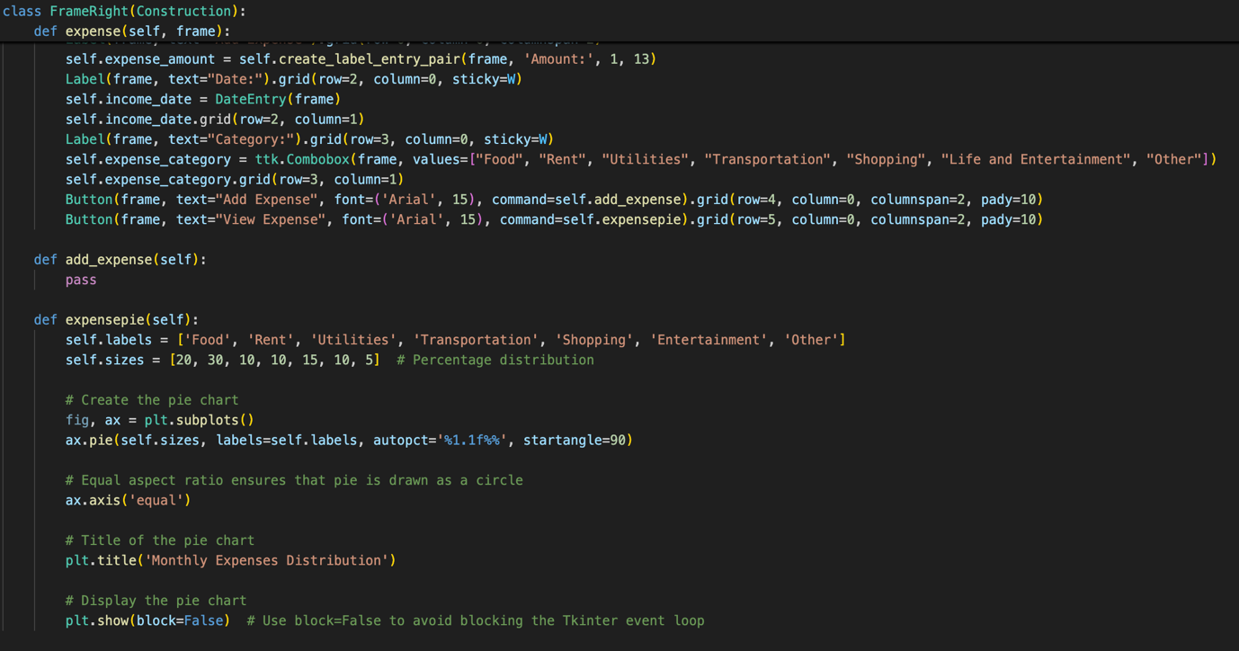

Fig 5.1.1: Code of piechart before update

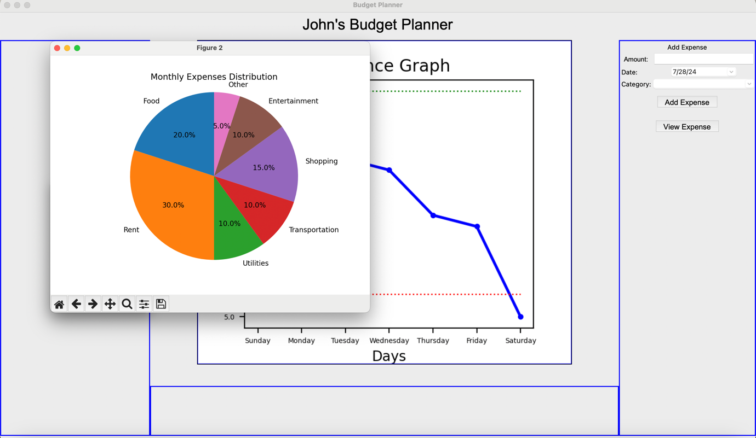

Fig 5.1.2: Intial GUI with piechart

Initially, as I was integrating a piechart to illustrate the proportion of expense in different categories, I had simply used the show() function thinking that the piechart would show when the button was pressed. However, it was seen for the whole programme to crash immediately after closing the piechart window. After much research, I found that the code crashes because the plt.show() function, used to display the pie chart, cannot run properly within the Tkinter event loop. This function blocks the execution and creates a new window for the plot, which interferes with Tkinter's mainloop.

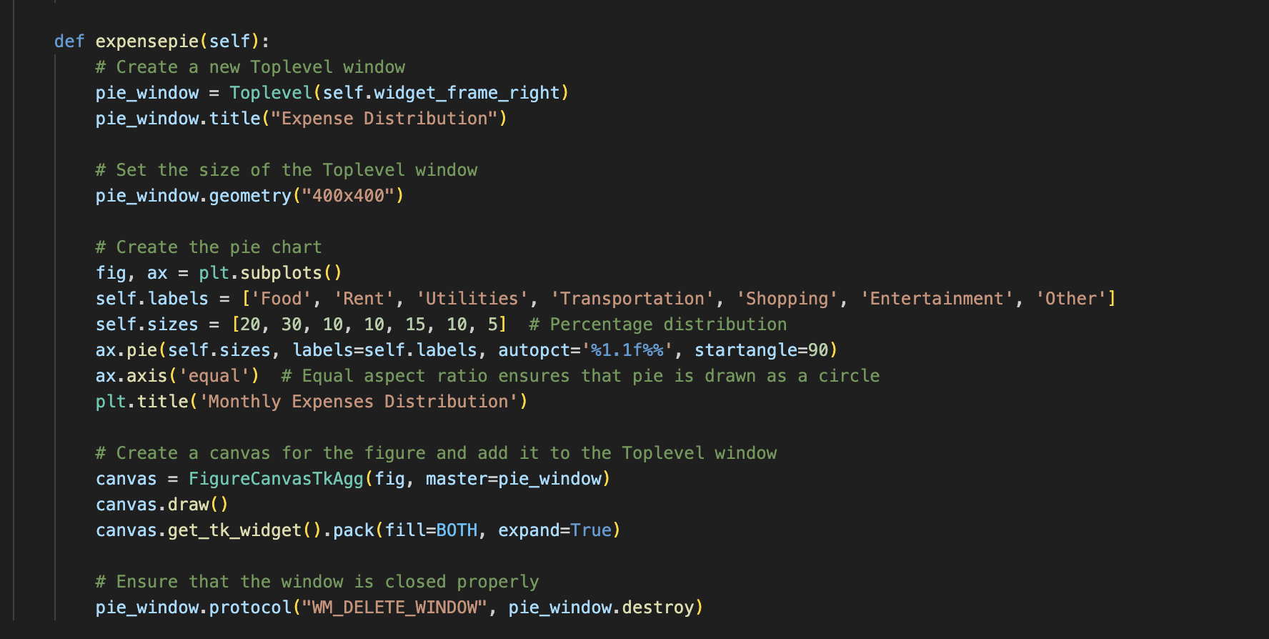

Fig 5.1.3: Revised code of piechart

After much thought, I decided to create a Toplevel window, make the piechart into an image using FigureCanvasTkAgg and embed that picture onto the window to prevent any disruption with the tkinter loop.

5.2 Testing for Evaluation

*5.2.1Login Window*

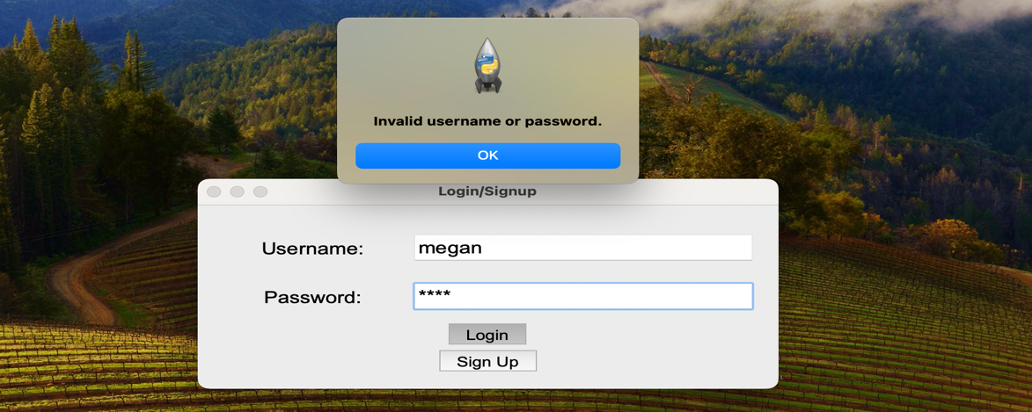

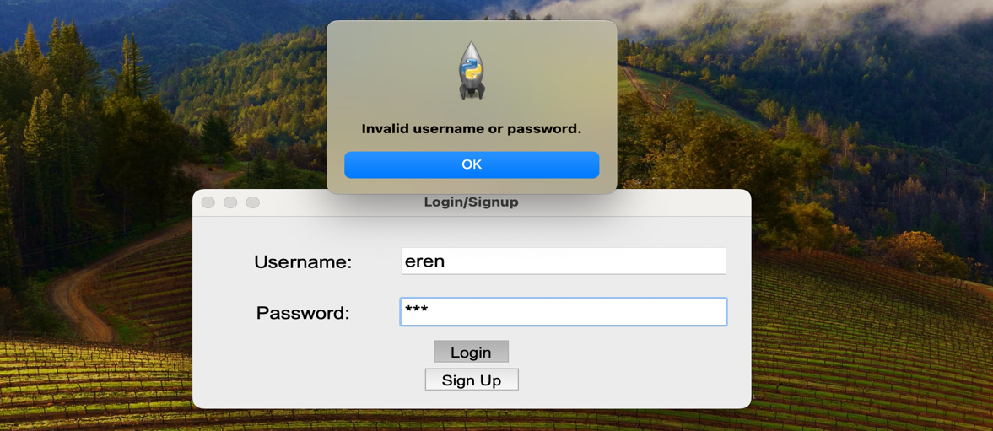

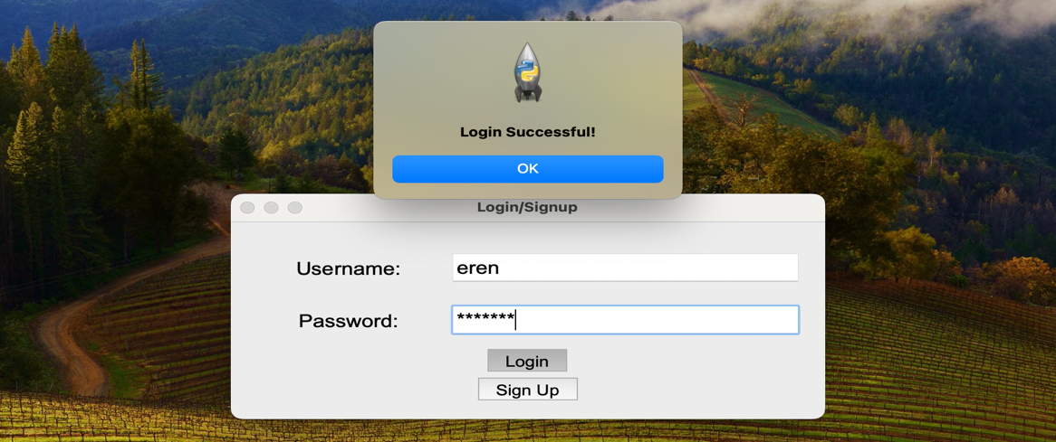

Fig 5.2.1a: Login GUI with different entries

Tested for invalid inputs for user and password Code was successful handling invalid inputs and would only proceed if input is valid.

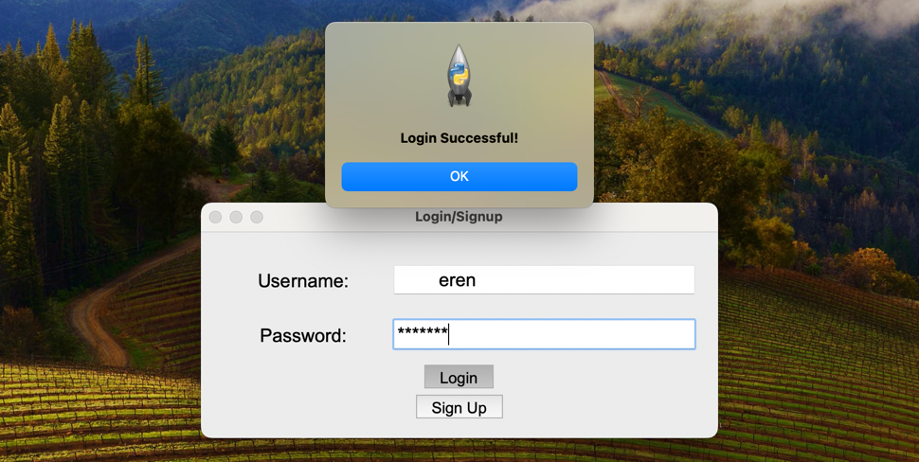

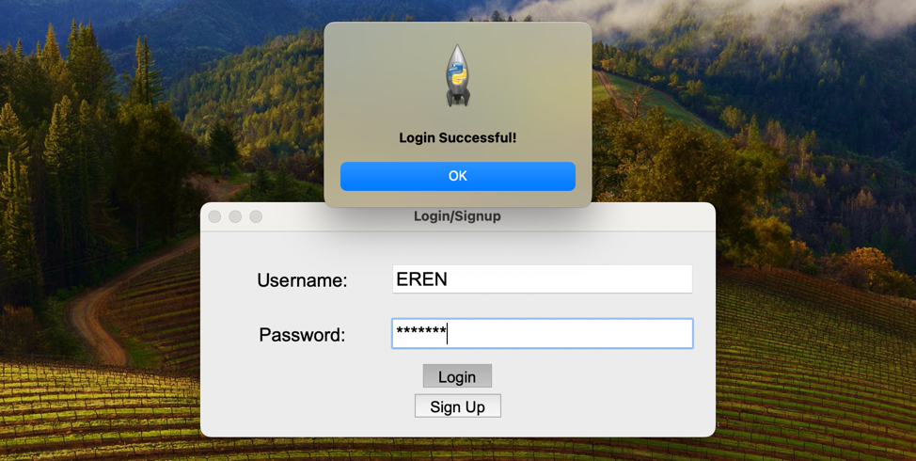

Fig 5.2.1b: Login GUI with different valid entries

Tested case insensitivity of username entry. Code was successful in handling these inputs and would still proceed.

*5.2.2 Sign-up Window*

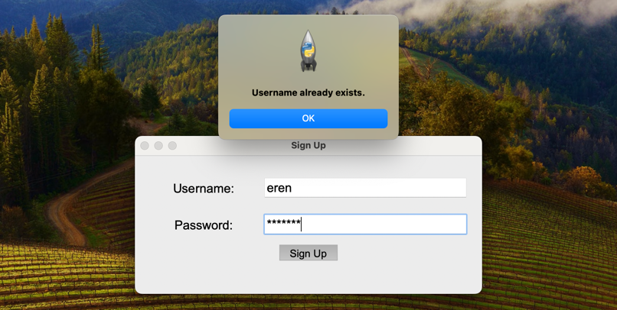

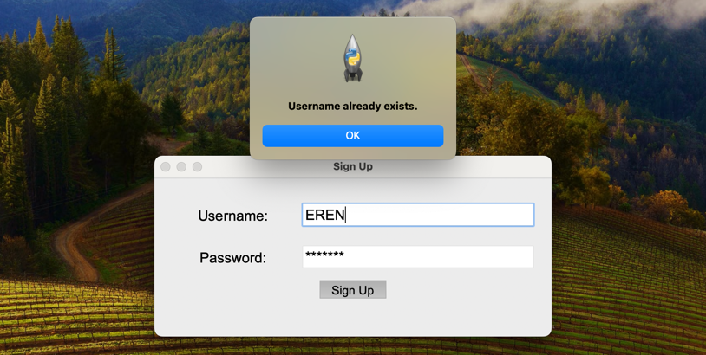

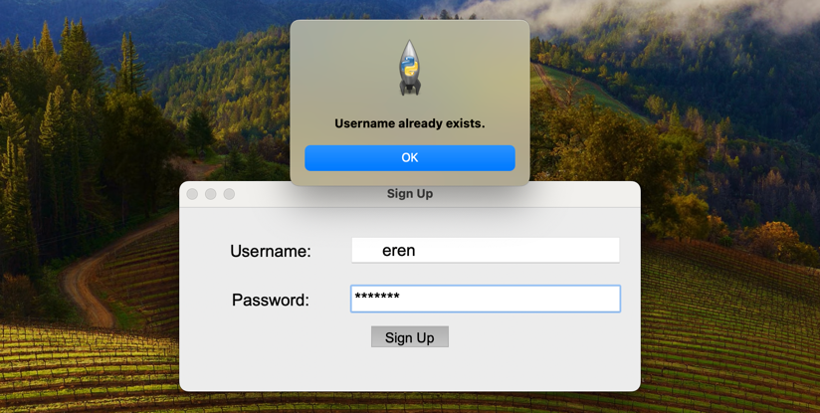

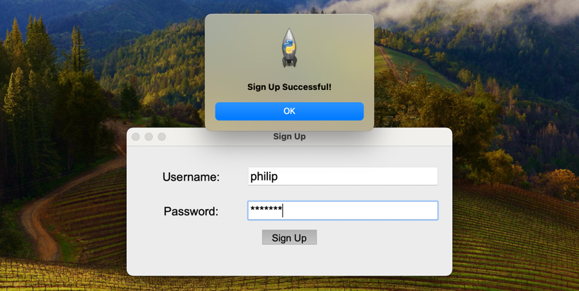

Fig 5.2.2a: Sign-up GUI with different entries

Tested for existing usernames. Code was successful in catching these usernames and would not add users unless they have a username that does not already exist within the csv file.

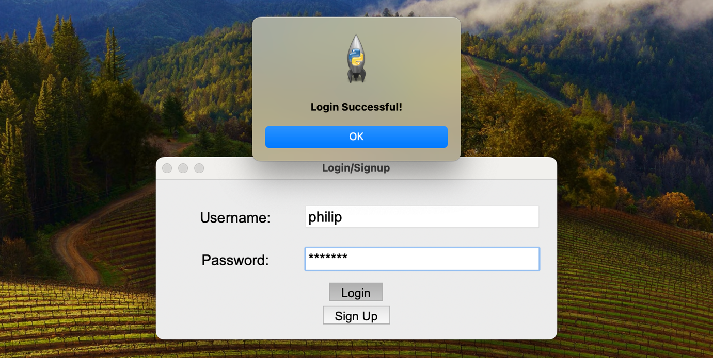

Fig 5.2.2a: Login GUI with a newly registered account

Code successfully stores data into the csv file via the sign up window.

*5.2.3 Main Window*

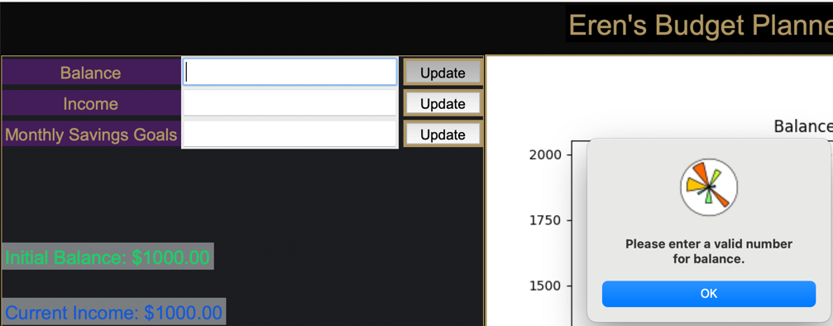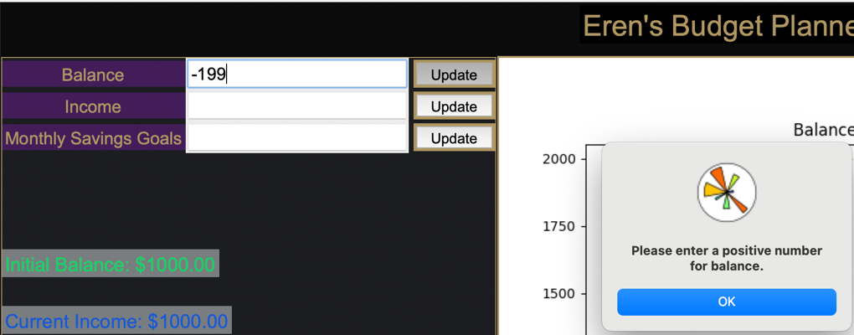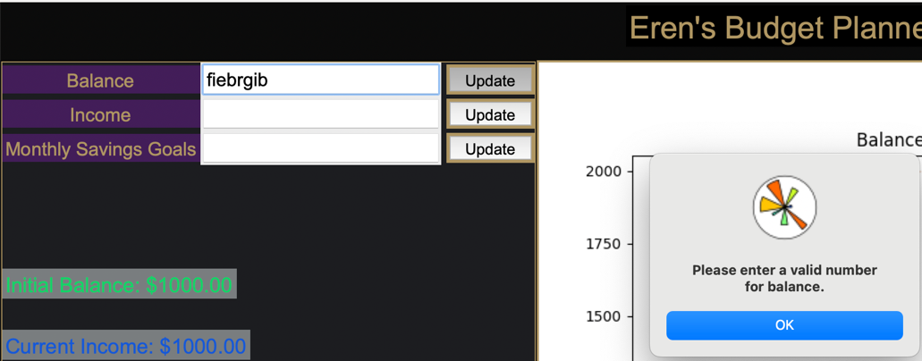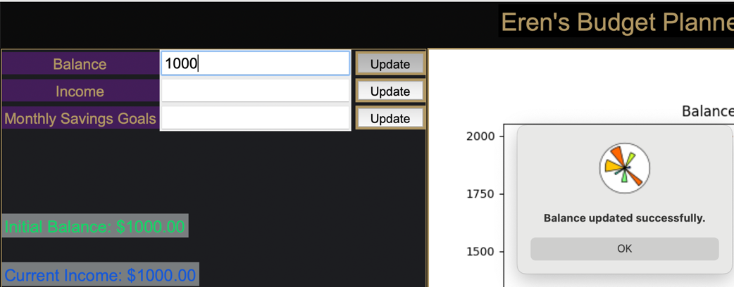

Fig 5.2.3a: Balance entry GUI with different entries

Tested for invalid entries for balance entry with various non integer and negative integers including a blank response. Code was successful handling invalid inputs and would only update user data if entry is valid.

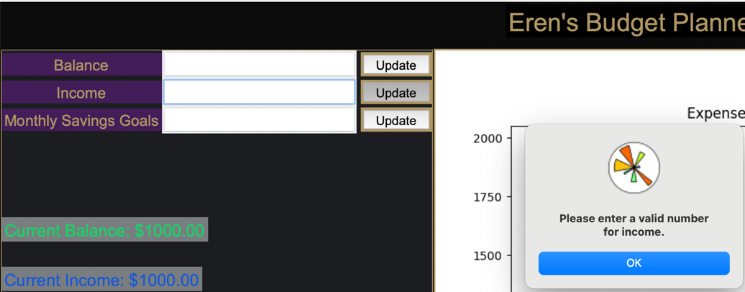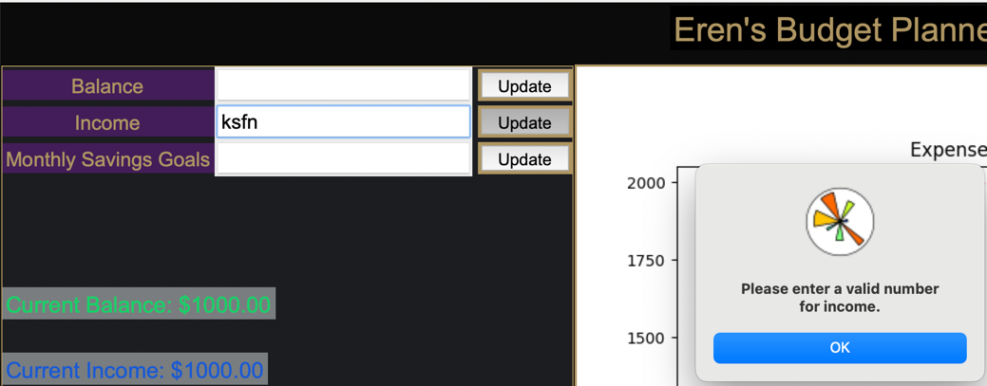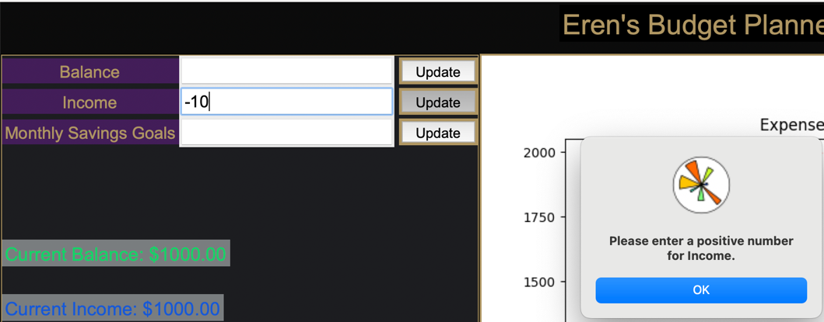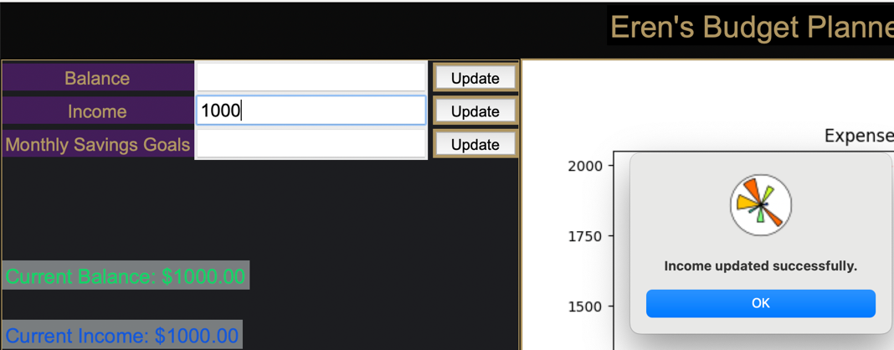

Fig 5.2.3b: Income entry GUI with different entries

Tested for invalid entries for income entry with various non integer and negative integers including a blank response. Code was successful handling invalid inputs and would only update user data if entry is valid.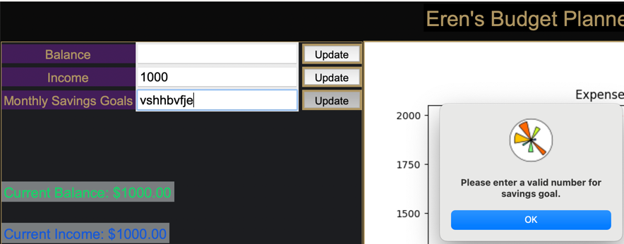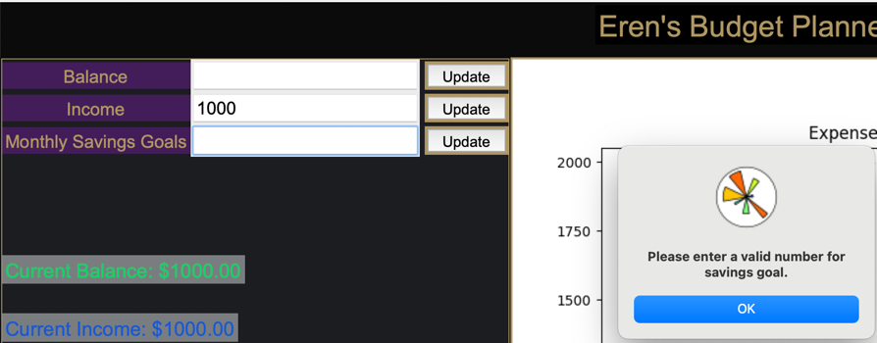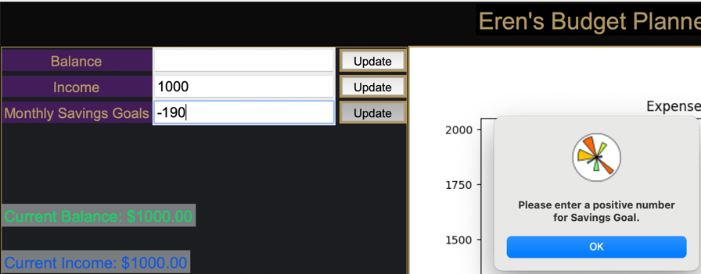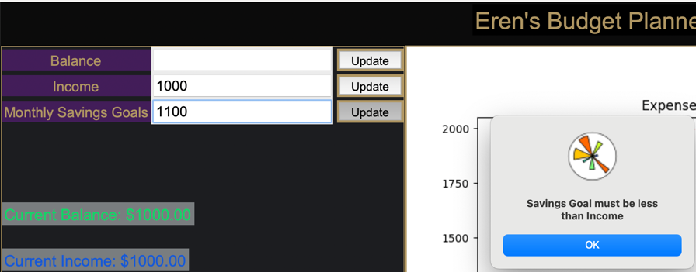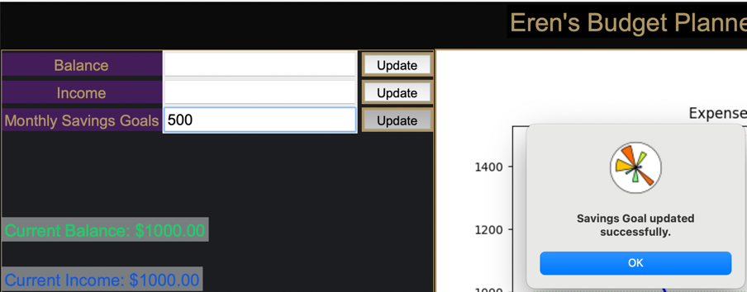

Fig 5.2.3c: Monthly Saving Goal entry GUI with different entries

Tested for invalid entries for Monthly Savings Goal entry with various non integer and negative integers including a blank response. Additionally, tested for the condition that the saving goal should be less than the income. Code was successful handling invalid inputs and would only update user data if entry is valid.

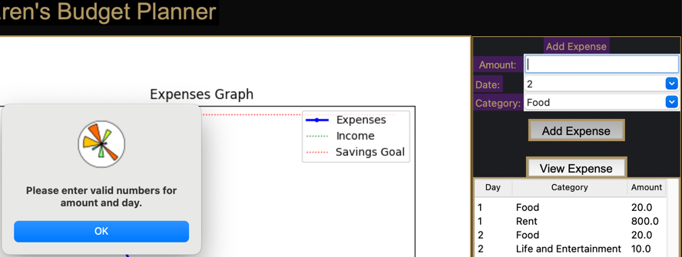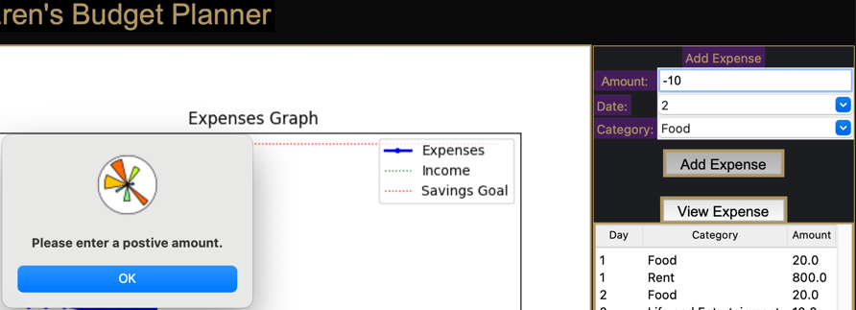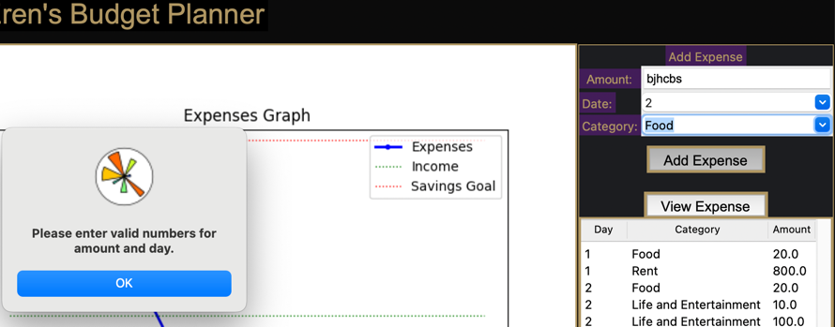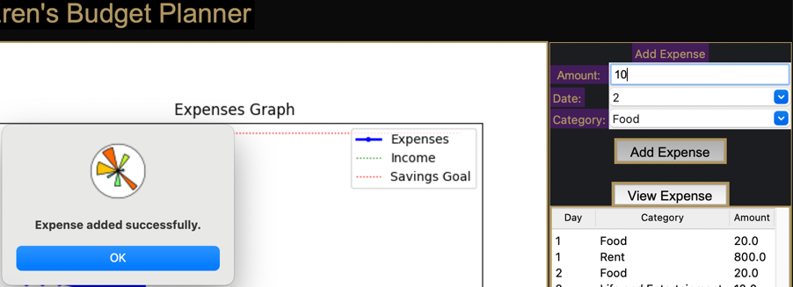

Fig 5.2.3d: Monthly Saving Goal entry GUI with different entries

Tested for invalid entries for expense entry with various non integer and negative integers including a blank response. Code was successful handling invalid inputs and would only update user data if entry is valid.

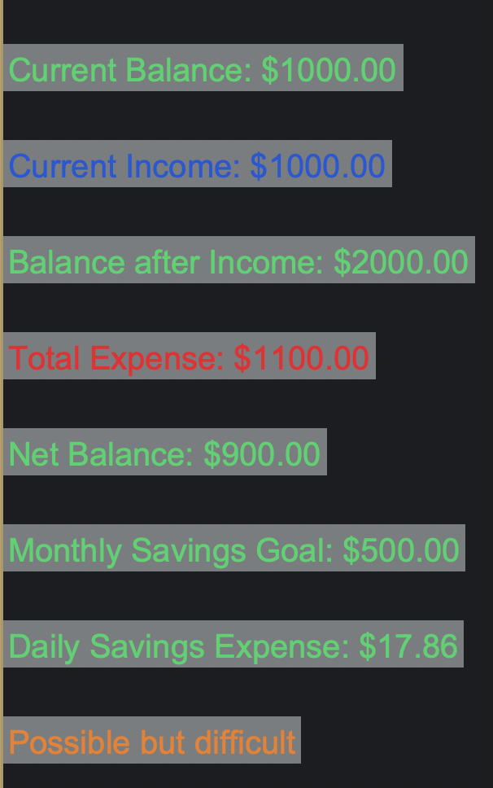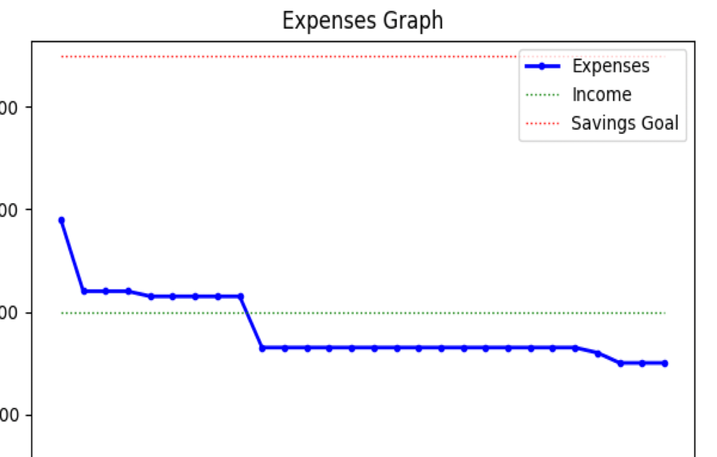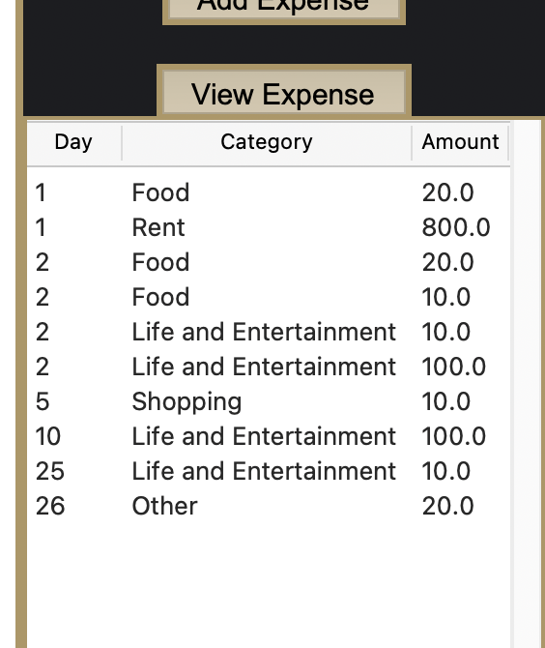

Fig 5.2.3e: Monthly Saving Goal entry GUI with different entries

From the successful entries, widgets were successful in updating data.

1. **Evaluation and Summary**

My Budget Tracker was an application aimed at offering users a platform for the setup of personal accounts, making entries, monitoring, and evaluation of their budgetary data. All these have been quite successfully realized with features such as user account management, data entry, and budget evaluation, all of which are facilitated by the Tkinter library in the creation of a user-friendly interface for the application. The first and foremost challenge was to learn Tkinter, which was unknown to me, including understanding how a responsive GUI is designed. Another challenge was handling the JSON data, for which I needed to learn proper data storage handling to keep its integrity. Overcoming these challenges deepened my understanding of these technologies and programming practices. Improvement areas for the next version include reporting and analytics with graphical tools, budget goals and alerts, and accessibility to mobile and web platforms. Overall, this project was an invaluable learning experience

Improvement ideas:

* improve design of Login/Sign-up window
* implement more functions in the main Window to enhance user experience (eg. Add User Settings Panel for users to change password, Add a clear data function if users want to start anew, etc.)
* Implement more graphs to illustrate other data

1. **References**

Built In. (2021). *__name__ in Python Explained*. [online] Available at: https://builtin.com/articles/name-python#:~:text=%E2%80%9CIf%20__name__%3D%3D%20 [Accessed 28 Jul. 2024].

Codemy.com (2020). *How to Center a Tkinter Window on the Screen - Python Tkinter GUI Tutorial #126*. [online] YouTube. Available at: https://www.youtube.com/watch?v=TdTks2eSx3c&ab_channel=Codemy.com [Accessed 28 Jul. 2024].

EDUCBA. (2021). *Tkinter Button Color | How to Color Button in Tkinter with examples?* [online] Available at: https://www.educba.com/tkinter-button-color/.

matplotlib.org. (n.d.). *matplotlib.axes.Axes.set_xticks — Matplotlib 3.8.0 documentation*. [online] Available at: https://matplotlib.org/stable/api/_as_gen/matplotlib.axes.Axes.set_xticks.html.

OpenAI (2024). *ChatGPT* . [online] ChatGPT. Available at: https://chatgpt.com/.

W3Schools (2019). *Python Classes*. [online] W3schools.com. Available at: https://www.w3schools.com/python/python_classes.asp.

www.tutorialspoint.com. (n.d.). *Python - Tkinter pack() Method*. [online] Available at: https://www.tutorialspoint.com/python/tk_pack.htm.